

LAB 5 – Improvement of a service business website

Design principles help us design websites that will make users more productive. Knowledge of the characteristics of human cognition also helps us to design websites that respect the strengths and limitations of users.

This laboratory aims to improve and expand the service business website developed at lab 4. During this laboratory, you will need to:

* Learn a JavaScript framework, jQuery, to get a responsive site.
* Think about the cognitive load your website has.
* Think about the use of icons (an important visual communication tool)
* Continue your design in relation to the design principles presented in Dr. Norman's book

*Design of Everyday* Things*.*



SUBMISSION DEADLINE

* Sunday, February 16, 2024, 11:59 p.m.



SUBMISSION METHOD

* In Brightspace, the lab 5 contains a link to your submission.
* Don't submit files. Submit a link to your GitHub repo as well as your web page for this lab. The link for Lab 5 should not be the same as the link for Lab 4. Keep both versions of the site separate.
* *WARNING: Any code or even "little piece of code" you take from such a stack overflow* or other website *should be accompanied by a comment that recognizes the source. You must, in your submission text, state "Code for X inspired by (html link)."*

1. Submit a pdf document consisting of the following:
   1. Group number
   2. Group members
   3. Link to the GitHub repository
   4. Each members contribution.
   5. Snapshots of the website created



INSTRUCTIONS / TUTORIALS TO FOLLOW

We are continuing our exploration of HTML/CSS/JavaScript technologies to build websites. This week we will use a framework called jQuery.

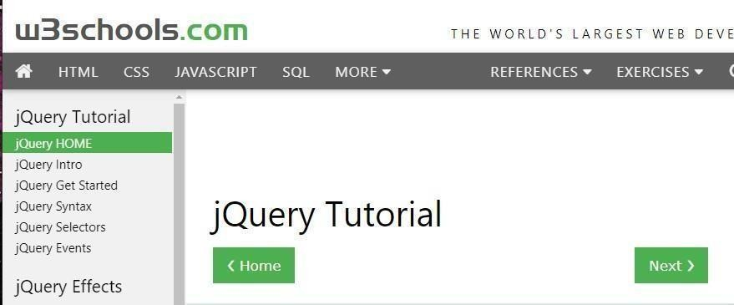You've seen so far that HTML/CSS is used to design your web page and that JavaScript allows actions (change of the DOM based on events).

jQuery is primarily used to help write JavaScript and make it easier to call functions that "react" to

various events occurring on the HTML page.

I suggest you use w3schools.com website, to explore what is possible to do with [jQuery. Y](https://www.w3schools.com/jquery/default.asp)ou can also use the code I provide you (see *Starting Point* section) which contains several small bits of code and links to the appropriate sections of the jQuery tutorial in the w3schools site.



In this lab, you must continue the development of your service business website that you started last week, either a hair salon or a bike repair shop. Depending on the new requirements requested in the *Programming* section, you may need to rethink some of the design.



STARTING POINT

I provided a [folder w](https://github.com/carolinebarriere/carolinebarriere.github.io/tree/master/SEG3125-Module5-ValidatedService)ith a bit of JavaScript code that shows the use of jQuery. You can see the [rendering here. I](https://carolinebarriere.github.io/SEG3125-Module5-ValidatedService/) suggest you browse through this code in which I have entered several comments and put links to appropriate sections of the tutorial offered by the w3schools as well as to other tutorials.

Don't forget that this is just a starting point, your site should reflect your design choices.



PROGRAMMING

Basic requirements of your page (Compulsory)

1. Two new **functional requirements:**
   1. Currently, your site demands to a user to choose a service (e.g. long cut, brake repair) and a date. Now, your site will also have to allow the user to choose the professional (hairdresser, mechanic) of his choice.
   2. In order to guarantee a reservation of services, the user must provide his credit card Information. You need to add a payment section to your site.
2. Requirements for **human cognition:**
   1. Warning: To ensure that the user "knows where he is" when he returns to the site, it is useful to add a menu, like a NavBar, at the top of the page. Users tend to look at the top of the page (focus point), and if they see a menu, this will be reassuring. The NavBar you use will actually be just a menu whose options bring the user back to a place in your page. You don't have to create other pages; your new menu will contain pointers in places on your page.
   2. Memory: Due to the brain’s short-term memory limitations, avoid having large menus (multiple sections). If you offer 10 types of services, for example, organize these services into subgroups.
   3. Perception: Think of these Gestalt's laws by looking at your site. For example:
      1. Law of Similarity: Do you have similar elements (same color, same icon) that help you see a group.
      2. Background law and form: do you have clearly visible icons on the various backgrounds. *iii.* Focus Law: Do you have a highlighted point (such as the navbar mentioned above).
3. Requirements for **visual communication tools:**

* Choosing good icons to use on a website is difficult, especially for actions or abstract concepts for which it is more difficult to find good metaphors or representations. To force you to think about the choice of icons, you need to add icons to:
  + Services o Experts
  + Payment
  + Two other elements of your choice

*You'll see in the starting code that I put icons not really appropriate but that come from a bank of icons*[*(Icons 8). T*](https://icons8.com/icons)*here are several other icon banks. You can also draw your own if you want. Also, look at one of my icons as it is visible on a white background, but not on a black background. You have to be careful about that.*

1. New requirements related to **the design principles** presented in Dr. Norman's book Design *of Everyday Things.* In the last laboratory, your requirements included visibility, affordance,

mapping, and consistency. In this lab, we will try to focus specifically on feedback and constraints, but also keep the other principles in mind.

***Visibility and affordance***: *I see what I can do, and I understand how to do it.*

* Help understand what information to provide and why:
  + Using *tooltips,* help the user understand what to provide as information and why. For example, asking for his credit card information may seem strange to him, and therefore it must be explained to him that it’s in case of a last-minute cancellation (or other reason).
* Increased entries:
  + When the user puts his mouse on an entry box, change the color of the input, for example, or accentuate that entry in another way.

***Constraints:*** *I can only make acceptable choices.*

* Input validation: When a user enters information into a text-type input component, they can write anything. You will need to use regular expressions to validate the format of the following entries:
  + Phone with format (xxx) xxx-xxxx (or other, of your choice) o

Credit card number with format "xxxx xxxx xxxx xxxx"

* Available dates limits: When the user chooses a date for their service, they are presented with a timetable. In this calendar, some dates will have to be unavailable.
  + Weekends (or Sunday/Monday, as you like)
  + Dates that do not correspond to the chosen professional. You will need to have a data table in your kind (Daniel, Tuesday-Wednesday-Thursday, Johanne,

Tuesday-Wednesday) that establishes the working days of each professional. Thus, when the user chooses Daniel for example, the only days of the available calendar should be Tuesday-Wednesday-Thursday.

*Warning: Regular expressions can become very complex. I'm only asking for fairly simple number validations, and I'm putting an example in the starting code. Also, for date validation, I suggest you use datepicker,* a *component of jQuery UI. I put an example in the starting code. Your challenge will be to hide certain days depending on the choice of the professional.*

**Feedback:** *What just happened? Did I make a* mistake*?*

* Entries errors: When a user enters information into a type “text” component, he can write anything. In addition to validating these entries (see section constraints) you need to give error messages.
* Any other feedback you feel is necessary to help the user understand what happened.

**Consistency:** *The site is uniform.*

* Choosing the jQuery UI theme related to the atmosphere of your site.

o jQuery UI offers themes for your components [https:/jqueryui.com/themeroller/](https://jqueryui.com/themeroller/) and you have to choose a theme that fits well with your site. You will see in the starting code that I have chosen a theme; you can change it.

* Choose icons related to the atmosphere of your site.
  + You need to add icons to your site, make sure you choose icons styles that represent the style of your website.



EVALUATION

* This lab is worth 3%.
* Any SUBMISSION with requested requirements will be granted 10/10.
* Failure to provide code-inspired sources of online code will result in a score of zero.



QUESTIONS

* You can also send your questions directly to TAs